JAVA
PIVOT ELEMENT:
CODE:
import java.util.*;
public class pivot {
public static void main(String[] args) {
int n=6;
int arr[] = {1,4,5,8,7,3};
int totalsum=0;
for(int i=0;i<n;i++){
totalsum+=arr[i];
}
int leftsum=0;
for(int i=0;i<n;i++){
int rightsum=totalsum-leftsum-arr[i];
if(leftsum==rightsum){
System.out.print(i);
return;
}
leftsum+=arr[i];
}
}
}
OUTPUT:
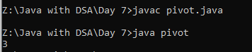
ARRAYLIST OPERATIONS:
CODE:
import java.util.*;
class operation{
public static void main(String[] args){
ArrayList<Integer> list=new ArrayList<>();
list.add(5);
list.add(21);
list.add(12);
list.add(19);
System.out.println("After Insertion:"+list);
list.remove(0);
System.out.println("After remove:"+list);
System.out.println("Get index 1:"+list.get(2));
System.out.println("Array size:"+list.size());
System.out.println("Is Empty ?:"+list.isEmpty());
}
}
OUTPUT:
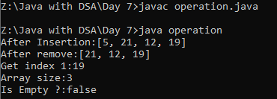
EMPLOYEE :
CODE:
import java.util.*;
class Employee{
int id;
String name;
String ed;
Employee(int id,String name,String ed){
this.id=id;
this.name=name;
this.ed=ed;
}
}
class Main{
public static void main(String[] args){
ArrayList<Employee> list=new ArrayList<>();
Employee e=new Employee(101,"abc","HR");
list.add(e);
for(Employee a:list){
System.out.println(a.id);
System.out.println(a.name);
System.out.println(a.ed);
}
}
}
OUTPUT:
